**Chapter 1**

**INTRODUCTION**

* 1. **Introduction to Web Development**

Web Development is the work involved in developing a web site for the internet. Web development can range from developing a simple single static page of plain text to complex web-based internet applications, electronic business, and social network services. For larger organization and businesses, web development teams can consist of hundreds of people and follow standard methods like agile methodologies while developing web sites. An ever-growing set of tools and technologies have helped developers build more dynamic and interactive web sites. Further web developers now help to deliver applications as web services which were traditionally only available as applications on desk-based computer. This has allowed for many opportunities to decentralize information and media distribution. In web development we use HTML (Hyper Text Markup Language), CSS (Cascading Style Sheets), PHP(Hypertext Preprocessor), JavaScript ..Etc.

* 1. **Brief Outline of Project**

The ATM/CDM System is a simulated working of an **Automated teller machine/Cash deposit machine**. The front end tool used to simulate this software database is My SQL. When a user enters his account number and his PIN he will be able to log into his Account. This is achieved by sending the login information to the database and verifying whether the credentials are matching the database records. If it matches the records then the user is able to login to his account to perform any transaction. Else he’ll be required to enter his credentials properly again.

After he has access to his account he can choose between 5 options which are:

1. Withdraw cash.
2. Deposit cash.
3. Enquire balance.
4. Generate a Mini Statement.
5. Change PIN Code.

Any of the option can be chosen choose based on his requirement. If he chooses Withdraw cash option then he will be redirected to a page where he can select if he wants to Withdraw from his Savings account or a Current account. Then he can enter the amount he wishes to withdraw and if the balance is sufficient in his account the transaction will be successful, else he will be redirected back to the login page with an alert that he has insufficient funds in his account. The amount entered should be in multiples of 100s only. The amount which is withdrawn will be updated in the database of the account holder. A transaction ID will be generated and presented to the user, which he can make note of. This is the same case of operation if he chooses the 2nd option which is the Deposit operation in which case he can deposit money into his account.

When the 3rd option that is, Enquire Balance is chosen, the user is presented with a page to choose between his savings account and his current account and that account’s balance is displayed on a new page. This balance will be the current balance pulled from the database.

When the 4th option that is, Mini Statement is chosen, the most recent 8 transactions of that account holder will be presented in the form of a table. The tuples of the table are Date, Time, Transaction number, Account Number, Account Type, Amount, Balance and Transaction Type. All of this tuple details will be pulled from the database and presented to the user.

The final 5th option is Change PIN option in which the user can change his account PIN Code by entering his Old PIN code, New PIN code and verifying his new PIN code. This information is sent to the database and the PIN code change is reflected in the database as well.

This a Brief outline of how the project operates.

**1.3 Project Goal**

The aim of this project is to speed up the transactions done by customers in a neat and easy to understand manner without too much complexities.

**1.4 Scope**

* It can be implemented in ATM machine by owner of bank or in charge of branch
* It is easy to learn the task.

**Chapter 2**

**REQUIREMENT SPECIFICATION**

Some of the basic requirements for the development of this project are as follows:

**2.1 Hardware Requirements**

* Processor : intel core i3
* Hard Disk : 20 GB, 80 GB, 160 GB or above
* Monitor : 15 VGA colour, 1024*768 resolution
* RAM : 2GB or above
* Input Device : Keyboard and Mouse

**2.2 Software Requirements**

* Operating System : Windows 10
* Tool used : Brackets and XAMPP
* Front end used : HTML/CSS/PHP
* Back end used : SQL

**Chapter 3**

## **3.1 User Interface Design**

The user interface used in any software must be user friendly. So, we have made PHP/HTML interface as our Front-end tool. PHP is being widely used in this era of web development. It is simple, user-friendly and HTML can be embedded within it.

To access PHP files we needed a server which is why we have used XAMPP server software which consists of Apache Server. By using this software we were able to access all our PHP pages and work on it. We used Sublime Text 3 software to code our webpages. This open-source tool can be used to code about 200 programming and scripting languages together. Finally with the help of XAMPP server software we were able to create a Database in Microsoft’s MySQL database. All the data required to run this system is stored in that database. It is highly convenient for developers and designers alike to connect MySQL database data and PHP webpages using simple SQL command queries. Any user can use our web interface and easily be able to sign-up, login to his account, make any desired transaction and exit the system with a Transaction ID (As long as its successful)

**Chapter 4**

**TESTING**

Testing is a dynamic technique of verification and validation. It involves executing an implementation of the software with test data and examining the outputs of the software and its operational behavior to check that it is performing as required.

The following statements serve as the objectives for testing:

1. Testing is a process of executing a program with the intent of finding error
2. A good test case is one that has a high probability of finding an as-yet undiscovered error.
3. A successful test is one that uncovers as-yet undiscovered error.

Verification and validation is intended to show that a system confirms to its specification and that the system meets the expectations of the customer. Verification involves checking that the software confirms to its specification. We should check that the system meets its specified functional and non-functional requirements. Validation ensures that the software meets the expectations of the customer. It goes beyond checking conformance of the system to its specification to showing that the software does what the customer expects as distinct from what has been specified.

The testing process should proceed in stages where testing is carried out incrementally in conjunction with system implementation. Figure 4.1 shows a five stage testing process where system components are tested, the integrated system is tested and, finally, the system is tested with the customer’s data.

The stages in the testing process are:

**4.1 Unit Testing**

Individual components are tested to ensure that they operate correctly. Each component is tested independently, without other system components. Thus the project has been successfully tested.

**4.2 Integration Testing**

Main function is design to call many sub functions, where different options are given in the sub functions. Now, different functions are included in the main separately and tested for error. Compile and tested the project without any error’s get the output as we expected. Thus the project has been successfully tested.

**4.3 Sub-system Testing**

This phase involves testing collections of modules which have been integrated into sub-systems. The sub-system test process should concentrate on the detection of module interface errors by rigorously exercising these interfaces. Thus the project has been successfully tested.

**4.4 System Testing**

The sub-systems are integrated to make up the system. This process is concerned with finding errors that result from unanticipated interactions between sub-systems and sub-system interface problems. It is also concerned with validating that the system meets its functional and non-functional requirements and testing the emergent system properties. Thus the project has been successfully tested.

**4.5 Acceptance Testing**

This is the final stage in the testing process before the system is accepted for operational use. The system is tested with data supplied by the system customer rather than simulated test data. Thus the project has been successfully tested.

**Chapter 5**

**SNAPSHOTS**

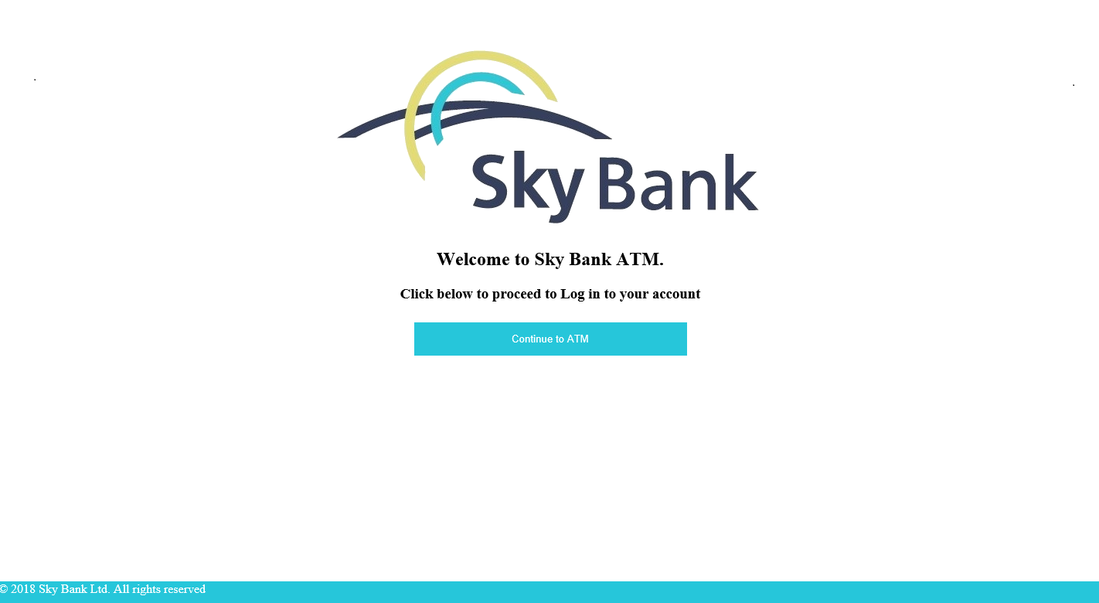

Fig. 5.1: Welcome Screen

The Fig. 5.1, shows the Welcome Screen of the ATM.

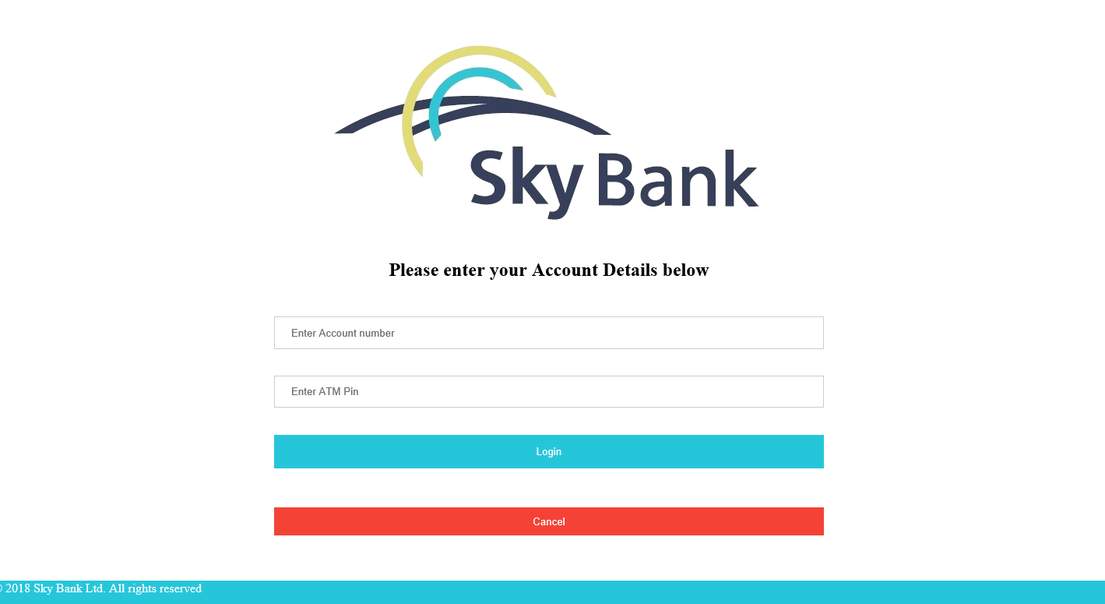

Fig. 5.2: Login Screen

The Fig. 5.2 shows the Login Screen of the ATM

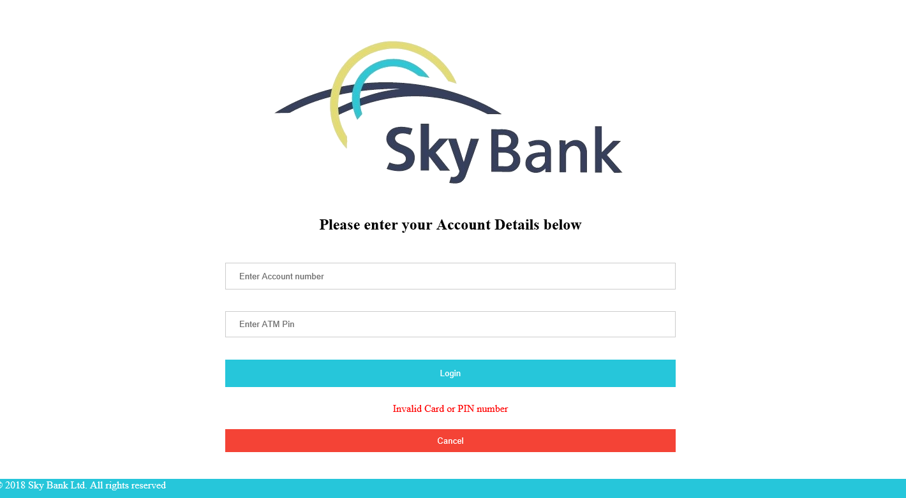

Fig .5.3: Login Failed Screen

The Fig. 5.2 shows the Failed Login Screen when the wrong PIN or Card Number is given

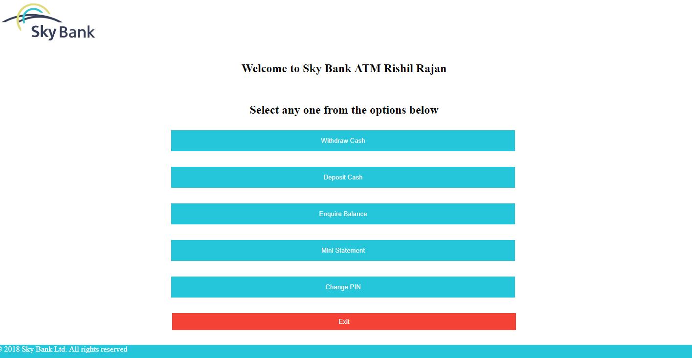

Fig .5.4: ATM Menu Screen

The Fig. 5.4 shows the available operations of the ATM

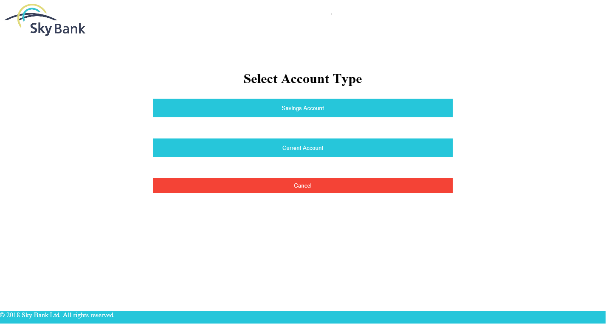

Fig .5.5: Select Account Type Screen

The Fig. 5.5 shows the Account Type Selection Screen

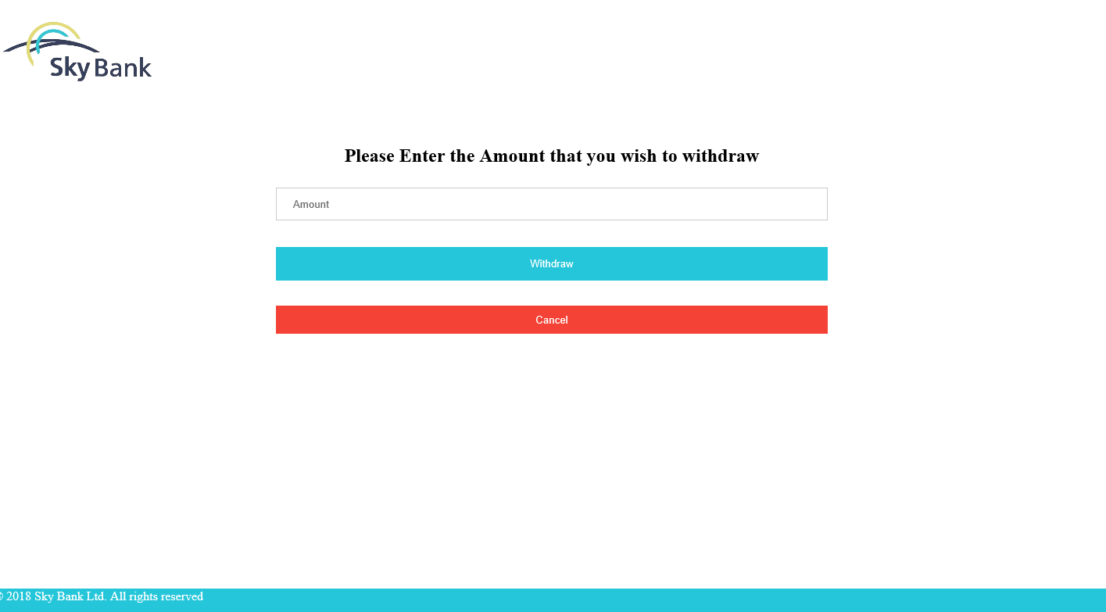

Fig. 5.6: Withdraw Screen

The Fig. 5.6 shows the Withdraw Screen of the ATM

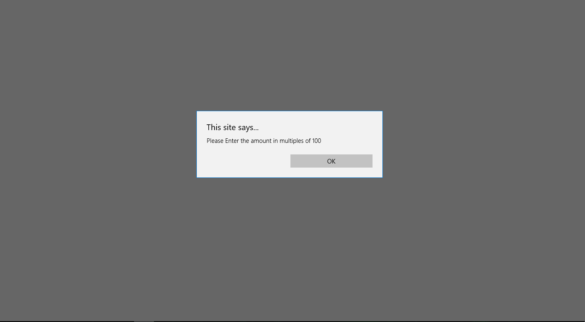

Fig.5.7: Withdraw Multiples Error Alert Screen

The Fig. 5.7 shows the error message displayed when multiples of 100 is not given as input

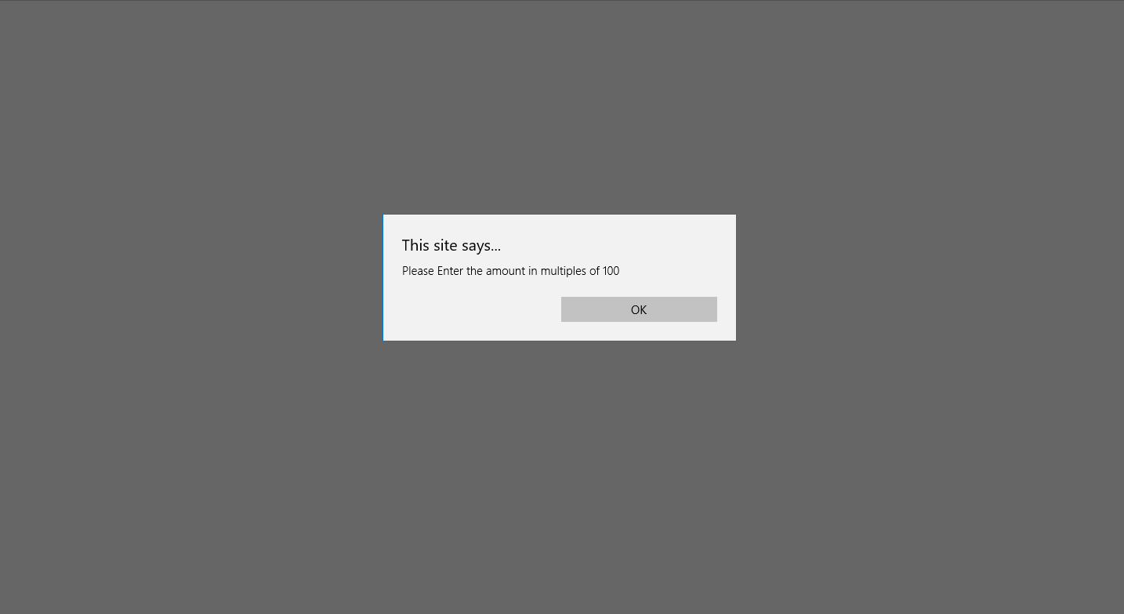

Fig. 5.8: Transaction Successful Screen

The Fig. 5.8 shows the Transaction successful screen

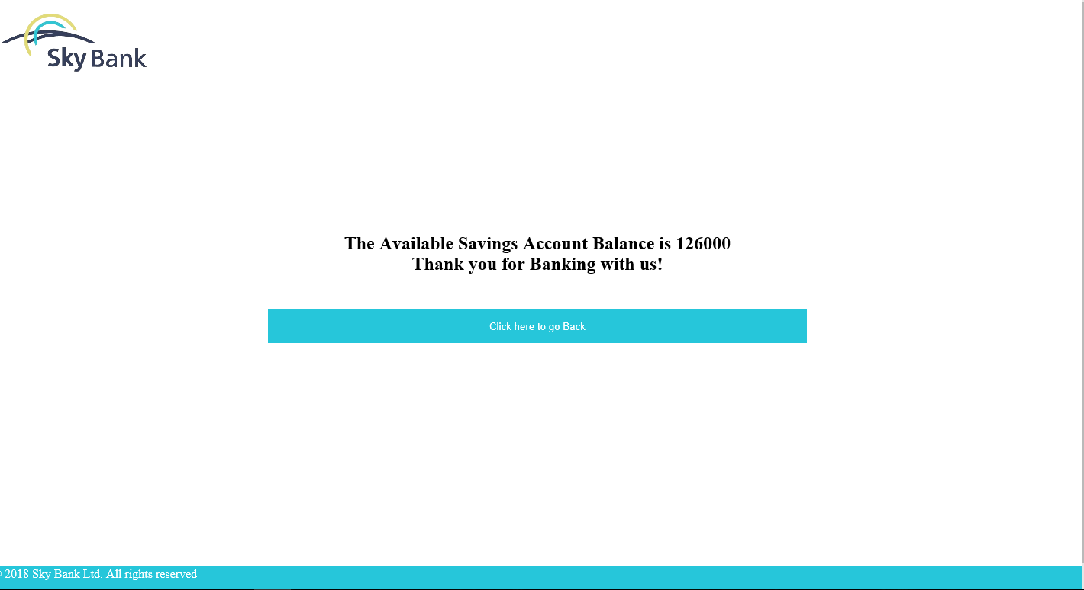

Fig. 5.9: Balance Amount Screen

The Fig. 5.9 shows the Balance of the customer

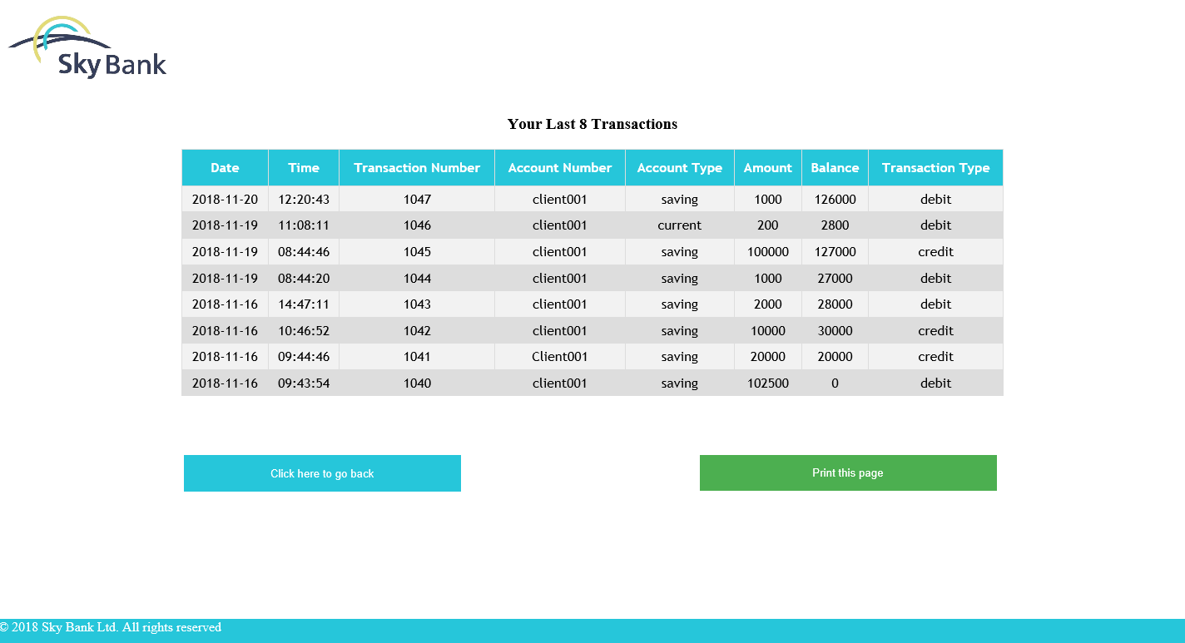

Fig. 5.10: Mini Statement Screen

The Fig. 5.10 shows the Mini Statement, which displays the last 8 transactions of the ATM

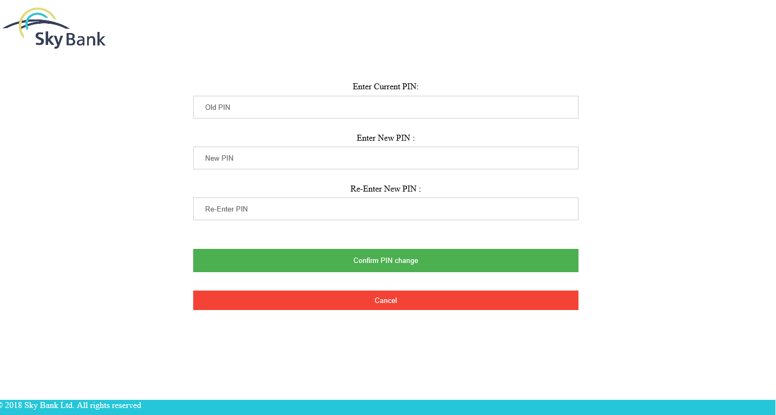

Fig. 5.11: Change PIN Screen

The Fig. 5.11 shows the Change PIN Screen of the ATM

**Chapter 6**

**CONCLUSION AND FUTURE ENHANCEMENTS**

**6.1 Conclusion**

The development of the mini project has given us a good exposure to HTML, CSS, PHP , JAVASCRIPT and SQL by which we have learnt some of the techniques which help in development of websites and manipulation of databases.Hence it is helpful for us even to take up this field as our career too and develop new websites and databases and improve existing ones and help create a more secure database.

**6.2 Future Enhancements**

The future developments that can be done to this project is, use of Bio-metric authentication can improve security as card and PIN is not secure enough.

**BIBLIOGRAPHY**

[1] Ramez Elmasri and Shamkant B.Navathe, ‘Database system model, Language, Design and application programming’, 7th Edition, 2017.

[2] Steven Holzner, ‘The complete Reference PHP’.

[3] Luke Welling, Laura Thomson, “PHP and MYSQL web Development”, 5th Edition Pearson Education, 2016

[4] Robin Nixon, ‘Learning PHP, MYSQL & Javascript with Jquery, CSS and HTML5’, 4th Edition, O’Reilly Publications, 2015

**APPENDIX**

**Source Code**

**atm2.php**

<html>

<head>

<title>Login</title>

<script type='text/javascript' src='authenticate.js'></script>

<meta name="viewport" content="width=device-width, initial-scale=1.0">

<link rel="stylesheet" type="text/css" href="uitheme.css">

<link rel="shortcut icon" href="icon.png" type="image/x-icon"/>

</head>

<body>

<div align="center">

<img src="logo.png">

<br>

<br>

<h2>Please enter your Account Details below</h2>

<br>

<form action="authenticate.php" method="POST" class="box">

<input name="username" type="text" placeholder="Enter Account number" >

<br>

<br>

<input name="password" type="password" placeholder="Enter ATM Pin" >

<br><br>

<button type="submit">Login</button>

<br>

<br>

</form>

<form action="index.php">

<button id= "abc" type="submit">Cancel</button>

</form>

</div>

</body>

<footer class="white"> &copy 2018 Sky Bank Ltd. All rights reserved

</footer>

</html>

**atm3a.php**

<!--authentication successful-->

<?php

session_start();

?>

<html>

<head>

<title>Welcome to Sky Bank ATM</title>

<link rel="stylesheet" type="text/css" href="uitheme.css">

<meta name="viewport" content="width=device-width, initial-scale=1.0">

</head>

<body>

<div align="center">

<div align="left" class="logo">

<img src="logo.png" alt="Sky Bank" height="100px" width="200px">

</div>

<?php

$conn=mysqli_connect('localhost','root','','atm');

$sql="select * from customer where c_id=(select c_id from account_details where acc_no='$_SESSION[db_usr]');";

$result=mysqli_query($conn,$sql);

if (mysqli_num_rows($result)>0)

{

while($row=mysqli_fetch_assoc($result))

{

echo "<div align='center' style='margin-top:20px'> <h2> Welcome to Sky Bank ATM " . $row["c_fname"] ." ".$row["c_lname"]. "<br>"."</h2></div>" ."<br>";

}

}

?>

<h2>Select any one from the options below</h2>

<form action="atmactw.php">

<button type="submit" name="Withdraw">Withdraw Cash</button>

<br>

</form>

<form action="atmactd.php">

<button type="submit" name="Deposit">Deposit Cash</button>

<br>

</form>

<form action="atmacbs.php">

<button type="submit" name="Balance">Enquire Balance</button>

<br>

</form>

<form action="transaction.php">

<button type="submit" name="Mini Statement">Mini Statement</button>

<br>

</form>

<form action="atm4e.php">

<button type="submit" name="Change Pin">Change PIN</button>

<br>

</form>

<form action="atm2.php">

<button id="abc" type="submit">Exit</button>

</form>

</div>

</body>

<footer class="white"> &copy 2018 Sky Bank Ltd. All rights reserved

</footer>

</html>

**atm3b.php**

<html>

<head>

<title>Login</title>

<script type='text/javascript' src='authenticate.js'></script>

<meta name="viewport" content="width=device-width, initial-scale=1.0">

<link rel="stylesheet" type="text/css" href="uitheme.css">

<link rel="shortcut icon" href="icon.png" type="image/x-icon"/>

</head>

<body>

<div align="center">

<img src="logo.png">

<br>

<br>

<h2>Please enter your Account Details below</h2>

<br>

<form action="authenticate.php" method="POST" class="box">

<input name="username" type="text" placeholder="Enter Account number" >

<br>

<br>

<input name="password" type="password" placeholder="Enter ATM Pin" >

<br><br>

<button type="submit">Login</button>

<p style="color:red;">Invalid Card or PIN number</p>

</form>

<form action="index.php">

<button id= "abc" type="submit">Cancel</button>

</form>

</div>

</body>

<footer class="white"> &copy 2018 Sky Bank Ltd. All rights reserved

</footer>

</html>

**atm4ac.php**

<!--withdraw cash-->

<html>

<head>

<title>WITHDRAW MONEY</title>

<script type='text/javascript' src='IDGen.js'></script>

<title>Withdrawal Form</title>

<link rel="stylesheet" type="text/css" href="uitheme.css">

<meta name="viewport" content="width=device-width, initial-scale=1.0">

</head>

<body>

<div align="center">

<div align="left" class="logo">

<img src="logo.png" alt="Sky Bank" height="100px" width="200px">

</div>

<br>

<br>

<h2>Please Enter the amount that you wish to Withdraw</h2>

<form method="POST" action="withdrawal_check_current.php">

<input name="amount" type="number" placeholder="Amount" >

<br>

<br>

<button type="submit">Withdraw</button>

</form>

<form action="atm3a.php">

<button id="abc" type="submit">Cancel</button>

</form>

</div>

</body>

<footer class="white"> &copy 2018 Sky Bank Ltd. All rights reserved

</footer>

</html>

**atm4as.php**

<!--withdraw cash-->

<html>

<head>

<title>WITHDRAW MONEY</title>

<script type='text/javascript' src='IDGen.js'></script>

<title>Withdrawal Form</title>

<link rel="stylesheet" type="text/css" href="uitheme.css">

<meta name="viewport" content="width=device-width, initial-scale=1.0">

</head>

<body>

<div align="center">

<div align="left" class="logo">

<img src="logo.png" alt="Sky Bank" height="100px" width="200px">

</div>

<br>

<br>

<h2>Please Enter the Amount that you wish to withdraw</h2>

<form method="POST" action="withdrawal_check_savings.php">

<input name="amount" type="number" placeholder="Amount" >

<br>

<br>

<button type="submit">Withdraw</button>

</form>

<form action="atm3a.php">

<button id="abc" type="submit">Cancel</button>

</form>

</div>

</body>

<footer class="white"> &copy 2018 Sky Bank Ltd. All rights reserved

</footer>

</html>

**atm4bc.php**

<!--deposit cash-->

<html>

<head>

<title>DEPOSIT MONEY</title>

<script type='text/javascript' src='IDGen.js'></script>

<title>Deposit Form</title>

<link rel="stylesheet" type="text/css" href="uitheme.css">

<meta name="viewport" content="width=device-width, initial-scale=1.0">

</head>

<body>

<div align="center">

<div align="left" class="logo">

<img src="logo.png" alt="Sky Bank" height="100px" width="200px">

</div>

<br>

<br>

<h2>Please Enter the Amount that you wish to deposit</h2>

<form method="POST" action="deposit_check_current.php">

<input name="amount" value="amount" type="number" placeholder="Amount" >

<br>

<br>

<button type="submit" value="Deposit">Deposit</button>

<br>

<br>

</form>

<form action="atm3a.php">

<button id="abc" type="submit">Cancel</button>

</form>

</div>

</body>

<footer class="white"> &copy 2018 Sky Bank Ltd. All rights reserved

</footer>

</html>

**atm4bs.php**

<!--deposit cash-->

<html>

<head>

<title>DEPOSIT MONEY</title>

<script type='text/javascript' src='IDGen.js'></script>

<title>Deposit Form</title>

<link rel="stylesheet" type="text/css" href="uitheme.css">

<meta name="viewport" content="width=device-width, initial-scale=1.0">

</head>

<body>

<div align="center">

<div align="left" class="logo">

<img src="logo.png" alt="Sky Bank" height="100px" width="200px">

</div>

<br>

<br>

<h2>Please Enter the Amount that you wish to deposit</h2>

<form method="POST" action="deposit_check_savings.php">

<input name="amount" value="amount" type="number" placeholder="Amount" >

<br>

<br>

<button type="submit" >Deposit</button>

<br>

<br>

</form>

<form action="atm3a.php">

<button id="abc" type="submit">Cancel</button>

</form>

</div>

</body>

<footer class="white"> &copy 2018 Sky Bank Ltd. All rights reserved

</footer>

</html>

**atm4cc.php**

<?php

session_start();

?>

<html>

<head>

<title>BALANCE ENQUIRY</title>

<meta name="viewport" content="width=device-width, initial-scale=1.0">

<link rel="stylesheet" type="text/css" href="uitheme.css">

</head>

<body>

<div align="center">

<div align="left" class="logo">

<img src="logo.png" alt="Sky Bank" height="100px" width="200px">

</div>

<br>

<br>

</div>

<?php

$conn=mysqli_connect('localhost','root','','atm');

$sql="select current_balance from current_account where c_id=(select c_id from account_details where acc_no='$_SESSION[db_usr]')";

$result=mysqli_query($conn,$sql);

if (mysqli_num_rows($result)>0)

{

while($row=mysqli_fetch_assoc($result))

{

echo "<div align='center' style='margin-top:150px'> <h2> The Available Current Account Balance is " . $row["current_balance"] . "<br>"."Thank you for Banking with us!"."</h2></div>" ."<br>";

}

}

?>

<form action="atm3a.php">

<div align="center">

<button type="submit" value="Submit">Click here to go Back</button>

</div>

</form>

</body>

<footer class="white"> &copy 2018 Sky Bank Ltd. All rights reserved

</footer>

</html>

**atm4cs.php**

<?php

session_start();

?>

<html>

<head>

<title>BALANCE ENQUIRY</title>

<meta name="viewport" content="width=device-width, initial-scale=1.0">

<link rel="stylesheet" type="text/css" href="uitheme.css">

</head>

<body>

<div align="center">

<div align="left" class="logo">

<img src="logo.png" alt="Sky Bank" height="100px" width="200px">

</div>

<br>

<br>

</div>

<?php

$conn=mysqli_connect('localhost','root','','atm');

$sql="select saving_balance from saving_account where c_id=(select c_id from account_details where acc_no='$_SESSION[db_usr]')";

$result=mysqli_query($conn,$sql);

if (mysqli_num_rows($result)>0)

{

while($row=mysqli_fetch_assoc($result))

{

echo "<div align='center' style='margin-top:150px'> <h2> The Available Savings Account Balance is " . $row["saving_balance"] . "<br>"."Thank you for Banking with us!"."</h2></div>" ."<br>";

}

}

?>

<form action="atm3a.php">

<div align="center">

<button type="submit" value="Submit">Click here to go Back</button>

</div>

</form>

</body>

<footer class="white"> &copy 2018 Sky Bank Ltd. All rights reserved

</footer>

</html>

**atm4e.php**

<!--change pin code-->

<!DOCTYPE html>

<html>

<head>

<title>CHANGE PIN</title>

<link rel="stylesheet" type="text/css" href="uitheme.css">

<meta name="viewport" content="width=device-width, initial-scale=1.0">

</head>

<body>

<div align="center">

<div align="left" class="logo">

<img src="logo.png" alt="Sky Bank" height="100px" width="200px">

</div>

<br>

<br>

<form method="POST" action="change_pin_check.php">

Enter Current PIN:

<br>

<input type="password" name="oldpin" placeholder="Old PIN"><br><br>

Enter New PIN :

<br>

<input type="password" name="pin" placeholder="New PIN"><br><br>

Re-Enter New PIN :

<br>

<input type="password" name="pin1" placeholder="Re-Enter PIN"><br><br><br>

<button type="submit">Confirm PIN change</button>

<br>

<br>

</form>

</div>

<div align="center">

<form action="atm2.php">

<button id="abc" type="submit">Cancel</button>

</form>

</div>

</body>

<footer class="white">&copy 2018 Sky Bank Ltd. All rights reserved

</footer>

</html>

**atmacbs.php**

<html>

<head>

<title>ACCOUNT TYPE</title>

<link rel="stylesheet" type="text/css" href="uitheme.css">

<meta name="viewport" content="width=device-width, initial-scale=1.0">

</head>

<body>

<div align="center">

<div align="left" class="logo">

<img src="logo.png" alt="Sky Bank" height="100px" width="200px">

</div>

<br>

<br>

<h1 align="center">Select Account Type </h1>

<form action="atm4cs.php">

<button type="submit" name="Savings">Savings Account</button>

<br>

<br>

</form>

<form action="atm4cc.php">

<button type="submit" name="Current">Current Account</button>

<br>

<br>

</form>

<form action="atm3a.php">

<button id="abc" type="submit">Cancel</button>

</form>

</div>

</body>

<footer class="white"> &copy 2018 Sky Bank Ltd. All rights reserved

</footer>

</html>

**atmactd.php**

<html>

<head>

<title>ACCOUNT TYPE</title>

<link rel="stylesheet" type="text/css" href="uitheme.css">

<meta name="viewport" content="width=device-width, initial-scale=1.0">

</head>

<body>

<div align="center">

<div align="left" class="logo">

<img src="logo.png" alt="Sky Bank" height="100px" width="200px">

</div>

<br>

<br>

<h1 align="center">Select Account Type</h1>

<form action="atm4bs.php">

<button type="submit" name="Savings">Savings Account</button>

<br>

<br>

</form>

<form action="atm4bc.php">

<button type="submit" name="Current">Current Account</button>

<br>

<br>

</form>

<form action="atm3a.php">

<button id="abc" type="submit">Cancel</button>

</form>

</div>

</body>

<footer class="white"> &copy 2018 Sky Bank Ltd. All rights reserved

</footer>

</html>

**amtactw.php**

<html>

<head>

<title>Choose Account type</title>

<link rel="stylesheet" type="text/css" href="uitheme.css">

<meta name="viewport" content="width=device-width, initial-scale=1.0">

</head>

<body>

<div align="center">

<div align="left" class="logo">

<img src="logo.png" alt="Sky Bank" height="100px" width="200px">

</div>

<br>

<br>

<h1 align="center">Select Account Type</h1>

<form action="atm4as.php">

<button type="submit" name="Savings">Savings Account</button>

<br>

<br>

</form>

<form action="atm4ac.php">

<button type="submit" name="Current">Current Account</button>

<br>

<br>

</form>

<form action="atm3a.php">

<button id="abc" type="submit">Cancel</button>

</form>

</div>

</body>

<footer class="white"> &copy 2018 Sky Bank Ltd. All rights reserved

</footer>

</html>

**atm_pin_check.php**

<?php

session_start();

$loginpin=$_SESSION['db_pass'];

$oldpin=$_POST['oldpin'];

$pin=$_POST['pin'];

$repin=$_POST['pin1'];

$conn=mysqli_connect('localhost','root','','atm');

if($pin==$repin&&$loginpin==$oldpin)

{

$sql="update account_details set atm_pin =$repin WHERE acc_no = '$_SESSION[db_usr]'";

mysqli_query($conn, $sql);

echo '<script language="javascript">';

echo 'alert("Pin Successfully Changed !!");window.location="atm3a.php"';

echo '</script>';

}

else

{

echo '<script language="javascript">';

echo 'alert("PIN incorrect or mismatched.");window.location="atm4e.php"';

echo '</script>';

}

?>

**deposit_check_current.php**

<?php

session_start();

date_default_timezone_set("Asia/Calcutta");

$time=date("H:i:s");

$date=date("Y/m/d");

$conn=mysqli_connect('localhost','root','','atm');

$amt=$_POST['amount'];

$tid=mysqli_query($conn,"select * from transaction_id");

$val=mysqli_fetch_assoc($tid);

if($amt==0)

{

echo '<script language="javascript">';

echo 'alert("Please Enter a valid amount ");window.location="atm4bc.php"';

echo '</script>';

}

if ($amt%100==0)

{

$sql="select current_balance from current_account where c_id=(select c_id from account_details where acc_no='$_SESSION[db_usr]');";

$result=mysqli_query($conn,$sql);

if (mysqli_num_rows($result)>0)

{

while($row=mysqli_fetch_assoc($result))

{

$trans=$val["t_id"];

++$trans;

$actamt=$row["current_balance"]+$amt;

$sql1="update current_account set current_balance =$actamt WHERE c_id=(select c_id from account_details where acc_no='$_SESSION[db_usr]')";

$sql2="call trans_current_with($trans,'$_SESSION[db_usr]',$amt,$actamt)";

$sql3="update transaction_id set t_id=$trans";

mysqli_query($conn,$sql1);

mysqli_query($conn,$sql2);

mysqli_query($conn,$sql3);

echo '<script language="javascript">';

echo 'alert("Thank you for banking with us\n\nYour Transaction Number is "+"'.$trans.'");window.location="atm4bc.php"';

echo '</script>';

}

}

}

else

{

echo '<script language="javascript">';

echo 'alert("Please enter amount in multiples of 100");window.location="atm4bc.php"';

echo '</script>';

}

?>

**deposit_check_savings.php**

<?php

session_start();

date_default_timezone_set("Asia/Calcutta");

$time=date("H:i:s");

$date=date("Y/m/d");

$conn=mysqli_connect('localhost','root','','atm');

$amt=$_POST['amount'];

$tid=mysqli_query($conn,"select * from transaction_id");

$val=mysqli_fetch_assoc($tid);

if($amt==0)

{

echo '<script language="javascript">';

echo 'alert("Please Enter a valid amount ");window.location="atm4bs.php"';

echo '</script>';

}

if ($amt%100==0)

{

$sql="select saving_balance from saving_account where c_id=(select c_id from account_details where acc_no='$_SESSION[db_usr]');";

$result=mysqli_query($conn,$sql);

if (mysqli_num_rows($result)>0)

{

while($row=mysqli_fetch_assoc($result))

{

$trans=$val["t_id"];

++$trans;

$actamt=$row["saving_balance"]+$amt;

$sql1="update saving_account set saving_balance =$actamt WHERE c_id=(select c_id from account_details where acc_no='$_SESSION[db_usr]')";

$sql2="call trans_saving_dep($trans,'$_SESSION[db_usr]',$amt,$actamt);";

$sql3="update transaction_id set t_id=$trans";

mysqli_query($conn,$sql1);

mysqli_query($conn,$sql2);

mysqli_query($conn,$sql3);

echo '<script language="javascript">';

echo 'alert("Thank you for banking with us\n\nYour Transaction Number is "+"'.$trans.'");window.location="atm4bs.php"';

echo '</script>';

}

}

}

else

{

echo '<script language="javascript">';

echo 'alert("Please enter amount in multiples of 100");window.location="atm4bs.php"';

echo '</script>';

}

?>

**index.php**

<html>

<head>

<title>Login</title>

<script type='text/javascript' src='authenticate.js'></script>

<meta name="viewport" content="width=device-width, initial-scale=1.0">

<link rel="stylesheet" type="text/css" href="uitheme.css">

<link rel="shortcut icon" href="icon.png" type="image/x-icon"/>

</head>

<body>

<div align="center">

<img src="logo.png">

<h2>Welcome to Sky Bank ATM.</h2>

<h3>Click below to proceed to Log in to your account</h3>

<form action="atm2.php">

<button type="submit" name="Continue to ATM">Continue to ATM</button>

</div>

</form>

</body>

<footer class="white"> &copy 2018 Sky Bank Ltd. All rights reserved

</footer>

</html>

**transaction.php**

<?php session_start()?>

<html>

<head>

<title>Mini-Statement</title>

<link rel="stylesheet" type="text/css" href="uitheme.css">

<meta name="viewport" content="width=device-width, initial-scale=1.0">

</head>

<body>

<div align="center">

<div align="left" class="logo">

<img src="logo.png" alt="Sky Bank" height="100px" width="200px">

</div></div>

<?php

$conn=mysqli_connect('localhost','root','','atm');

$sql="select * from transaction where acc_no='$_SESSION[db_usr]' order by t_id DESC";

$result=mysqli_query($conn,$sql);

if (mysqli_num_rows($result)>0)

{

$i=0;

echo "<div align='center'><h3>Your Last 8 Transactions </h3></div>";

echo "<table id=tab>

<tr>

<th>Date</th>

<th>Time</th>

<th>Transaction Number</th>

<th>Account Number</th>

<th>Account Type</th>

<th>Amount</th>

<th>Balance</th>

<th>Transaction Type</th>

</tr>";

while($row=mysqli_fetch_assoc($result))

{

if($i<8)

{

echo "<tr>

<td>".$row["date"]."</td>

<td>".$row["time"]."</td>

<td>".$row["t_id"]."</td>

<td>".$row["acc_no"]."</td>

<td>".$row["account_type"]."</td>

<td>".$row["t_amount"]."</td>

<td>".$row["t_balance"]."</td>

<td>".$row["t_type"]."</td>

</tr>";

$i++;

}

}

echo "</table>"."<br>";

echo "<form action='atm3a.php'>

<button id= 'abc' type='submit' style='margin-left:-620px;width: 25em; height: 3.3em;'>Click here to go back</button>

</form>";

}

else

{

echo "<div align='center' style='margin-top:110px;'><h2><i>There are No Recent Transactions </i></h2></div>";

echo "<form action='atm3a.php'>

<button id= 'abc' type='submit' style='margin-left:-620px;width: 25em; height: 3.3em;'>Click here to go back</button>

</form>";

}

?>

<button id="printbutton" onclick="window.print();">Print this page</button>

</body>

<footer class="white"> &copy 2018 Sky Bank Ltd. All rights reserved

</footer>

</html>

**withdrawal_check_current.php**

<?php

session_start();

date_default_timezone_set("Asia/Calcutta");

$time=date("H:i:s");

$date=date("Y/m/d");

$conn=mysqli_connect('localhost','root','','atm');

$amt=$_POST['amount'];

$sql="select current_balance from current_account where c_id=(select c_id from account_details where acc_no='$_SESSION[db_usr]');";

$result=mysqli_query($conn,$sql);

$tid=mysqli_query($conn,"select * from transaction_id");

$val=mysqli_fetch_assoc($tid);

if($amt==0)

{

echo '<script language="javascript">';

echo 'alert("Please Enter a valid amount !!");window.location="atm4ac.php"';

echo '</script>';

}

if($amt%100==0)

{

if (mysqli_num_rows($result)>0)

{

while($row=mysqli_fetch_assoc($result))

{

if ($row["current_balance"]>=$amt)

{

$trans=$val["t_id"];

++$trans;

$actamt=$row["current_balance"]-$amt;

$sql1="update current_account set current_balance =$actamt WHERE c_id=(select c_id from account_details where acc_no='$_SESSION[db_usr]')";

$sql2="call trans_current_with($trans,'$_SESSION[db_usr]',$amt,$actamt)";

$sql3="update transaction_id set t_id=$trans";

mysqli_query($conn,$sql1);

mysqli_query($conn,$sql2);

mysqli_query($conn,$sql3);

echo '<script language="javascript">';

echo 'alert("Thank you for banking with us!!\n\nYour Transaction Number is "+"'.$trans.'");window.location="index.php"';

echo '</script>';

}

else

{

echo '<script language="javascript">';

echo 'alert(" You have Insufficient funds in your account");window.location="atm4ac.php"';

echo '</script>';

}

}

}

}

else

{

echo '<script language="javascript">';

echo 'alert("Please Enter the amount in multiples of 100");window.location="atm4ac.php"';

echo '</script>';

}

?>

**withdrawal_check_current.php**

<?php

session_start();

$conn=mysqli_connect('localhost','root','','atm');

$amt=$_POST['amount'];

date_default_timezone_set("Asia/Calcutta");

$time=date("H:i:s");

$date=date("Y/m/d");

$sql="select saving_balance from saving_account where c_id=(select c_id from account_details where acc_no='$_SESSION[db_usr]');";

$result=mysqli_query($conn,$sql);

$tid=mysqli_query($conn,"select * from transaction_id");

$val=mysqli_fetch_assoc($tid);

if($amt==0)

{

echo '<script language="javascript">';

echo 'alert("Please Enter a valid amount");window.location="atm4as.php"';

echo '</script>';

}

if($amt%100==0)

{

if (mysqli_num_rows($result)>0)

{

while($row=mysqli_fetch_assoc($result))

{

if ($row["saving_balance"]>=$amt)

{

$trans=$val["t_id"];

++$trans;

$actamt=$row["saving_balance"]-$amt;

$sql1="update saving_account set saving_balance =$actamt WHERE c_id=(select c_id from account_details where acc_no='$_SESSION[db_usr]')";

$sql2="call trans_saving_with($trans,'$_SESSION[db_usr]',$amt,$actamt);";

$sql3="update transaction_id set t_id=$trans";

mysqli_query($conn,$sql1);

mysqli_query($conn,$sql2);

mysqli_query($conn,$sql3);

echo '<script language="javascript">';

echo 'alert("Thank you for banking with us!!\n\nYour Transaction Number is "+"'.$trans.'");window.location="index.php"';

echo '</script>';

}

else

{

echo '<script language="javascript">';

echo 'alert(" You have Insufficient funds in your account");window.location="atm4as.php"';

echo '</script>';

}

}

}

}

else

{

echo '<script language="javascript">';

echo 'alert("Please Enter the amount in multiples of 100");window.location="atm4as.php"';

echo '</script>';

}

?>